**Modifying the Shiller Cyclically Adjusted Price-to-Earnings (CAPE) Ratio**

Yuchen Cao, Jian Chen, Tianyi Chen, Jin Ding, Lay Jain, Boyang Li, Jizheng Luan, Jingya Qi, Samson Qian, Hizkia Susanto, Ziyan Wang, Xiaoming Xu, Lingyun Ye

15.451 - Proseminar in Capital Markets/Investment Management

Advisor: Professor Mark Kritzman

Sponsor: Eric Ngiam, GIC

December 02, 2021

**Abstract**

The Shiller Cyclically Adjusted P/E (CAPE) is a metric commonly used to assess whether the stock market is over-, under-, or fairly valued. Compared to the regular price-to-earnings ratio, this ratio takes a 10-year average of company earnings to account for cyclical changes in the economy that can temporarily affect earnings for a fiscal year. During the dot-com bubble, the framework was able to correctly predict that the U.S. stock market had become too overvalued and warned of a crash. However, the CAPE ratio itself has many limitations and flaws that have affected its usefulness in measuring whether the equity market is overvalued or not. Because of changing economic trends and policies, many presumptions that the original CAPE relies on may no longer hold to a significant degree. Such trends include changes to interest rate regimes, accounting rules, tax regulations and tax rates, and the market index composition. These changes all have an impact on the effectiveness of the CAPE ratio to correctly value the market. In this report, we analyze recent changes in these trends and how they have impacted the CAPE ratio compared to before, and propose modifications to the original CAPE ratio to account for these changes. We then perform regression analysis of these adjusted CAPE values on the 10-year annualized stock return for the original time period that Shiller used (1881-2006), the modern time period (2007-2011), and the entire overall period. We demonstrate that the adjustments we made to the original Shiller CAPE formula provides better explanatory power than the original itself, and can be used to assess the relative market value compared to past levels. Finally, we discuss implications for these findings and propose applications of the adjusted CAPE ratios we devised.

**Acknowledgments**

We would like to thank Professor Mark Kritzman for his guidance and suggestions for the topics explored in this paper, and for regularly checking in with our team about progress and providing useful feedback. We also would like to thank Mr. Eric Ngiam from GIC of Singapore for providing the idea and foundation for the research and analysis done in this project.

**1. Introduction**

The Cyclically Adjusted Price-to-Earnings (CAPE) ratio was developed by John Campbell, an economics professor at Harvard University, and Robert Shiller, a Nobel laureate and an economics professor at Yale University. It is a valuation measure used to forecast the returns from equities over a long-term horizon, typically 10 to 20 years, determining whether a stock is undervalued or overvalued. Investors typically apply CAPE ratio to the S&P 500, which has been thought of as the best representation of the U.S. equities market.

The ratio was first introduced in Campbell and Shiller (1997)1, along with an ominous discovery that the CAPE ratio at that time was at an all-time high. This was a period when market participants were overly bullish on the commercialization of the Internet. The paper concluded that the stock market will eventually crash, thus predicting the dotcom bubble in the early 21st century, thus gaining popularity among investors.

**1.1 Background & History of CAPE**

CAPE ratio is a variant of a more popular price-to-earnings (P/E) ratio used to value stocks. In contrast to the P/E ratio, where the denominator is trailing twelve months (TTM) earnings, the denominator in CAPE uses average earnings, adjusted for inflation, across the past 10 years. Mathematically, CAPE can be expressed as:



Its formulation came from a long-standing belief, backed by empirical observations, that one-year earnings were too volatile to predict the direction of stock returns correctly. On the other hand, real earnings averaged over a longer horizon, typically between 5 to 10 years, were shown to be correlated to future stock returns. In addition, averaging across 10 years eliminates the effect of aberrations from business cycle, as businesses and economies often experience a boom and recession within a 10-year period. The figures below show the contrast between historical PE ratio (left) and CAPE ratio (right).

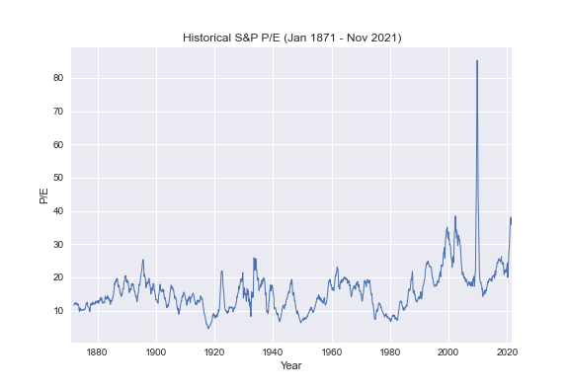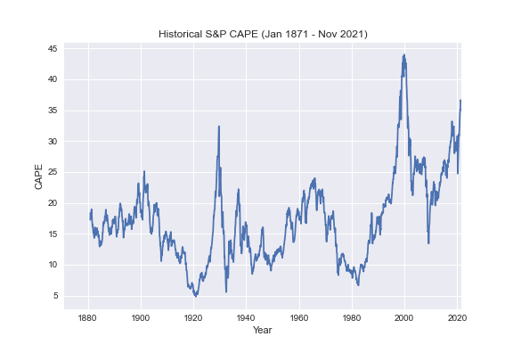

An important assumption of CAPE ratio is that it is mean-reverting. Because a stock price is reflective of the market’s belief on the business’ true future earning power, the stock price cannot deviate too far from its earnings. If a stock is overvalued or undervalued, then there will eventually be a shift, either in the numerator or the denominator, that will restore the CAPE ratio to a more normal level.

**1.2 Historical Performance of CAPE**

Aside from predicting the 2000 dotcom bubble, the CAPE ratio was also abnormally high in the periods preceding the 1929 Great Depression and the 1981 Great Inflation.

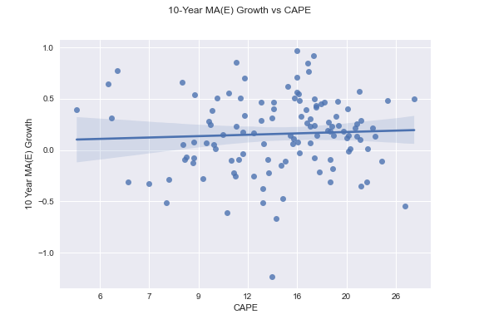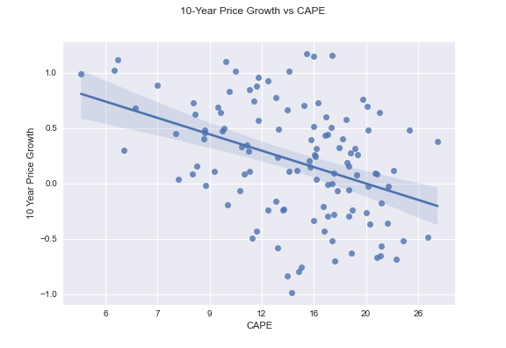

| **Endogenous variable** | **R2** | **p-value** |
| --- | --- | --- |
| **10Y MA(E) Growth** | 0.003 | 0.59 |
| **10Y Price Growth** | 0.158 | 0.00 |

As discussed above, the CAPE ratio is based on the belief in price correction, either on the price (numerator) or earnings (denominator). The figures and table above illustrate the result of performing linear regression on 10-year average earnings growth and 10-year price growth, adjusted for inflation, against the log of CAPE, using the equation below.



CAPE ratio does not perform well in forecasting the average earnings growth in the next 10 years, with a low R2 score of 0.003 and a p-value of coefficient of log(CAPE) of 0.59, indicating that there is a high probability that the average earnings are uncorrelated with CAPE ratio. On the other hand, CAPE ratio is shown to be a good predictor of 10-year price growth, as the R2 score of the regression is 0.158, with a p-value of 0.0, indicating that there is indeed a linear, specifically negative, correlation between 10-year price growth and CAPE ratio.

The economic intuition behind this finding is that while the CAPE ratio does not predict the equities market earnings, it predicts when the market is being overly bullish or bearish, thus overvaluing or undervaluing the stock market respectively. It is negatively correlated with price growth, as expected from the belief that when CAPE is in the extremes, there will be price correction that reverts the price back to a normal level.

The plots above also illustrate the ratio’s ability to identify periods of extremes much better than periods of normal CAPE ratios. The residual errors around a CAPE ratio range of 10-20 are larger than that when the CAPE ratio is extremely low or high. Intuitively, when the CAPE ratio is at a normal level, the CAPE ratio may not be able to predict whether the market will be bullish or bearish in the next 10 years, while at extreme levels, the CAPE predicts market correction in the next 10 years.

**1.3 Limitations of CAPE**

There are certain problems with the original CAPE ratio that affects the practicality of implementing it in a trading strategy for the market. The ratio has been high recently and continuously indicates that the current market is overvalued and that long-term value investors should not buy yet. Nevertheless, the S&P 500 index continues rising at great levels despite the high CAPE ratio, and consequently, investors who relied on CAPE made very few trades because the ratio rarely went below its average across the recent years.

This phenomenon is illustrated in the figures below, where the CAPE ratio mean has shifted significantly between the 1886-2007 period and the subsequent period until now. As CAPE’s utility relies on prior knowledge about the normal range of CAPE, this distortion results in the ratio losing its relevance.

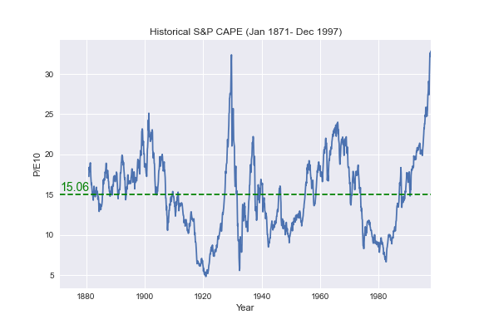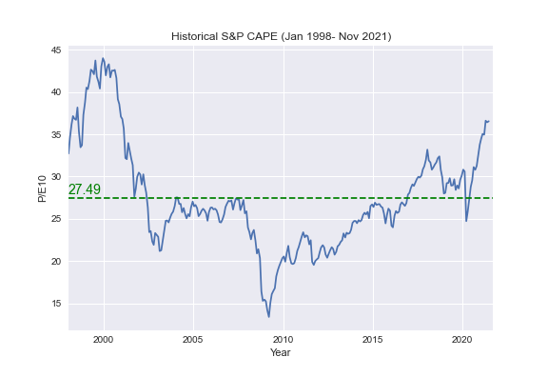

Performing a unit root test on historical CAPE, using Augmented Dickey-Fuller (ADF) with a constant and no trend, and Akaike Information Criterion (AIC) to determine the number of lags considered, shows that at 10% significance level, CAPE ratio is stationary in the 1886-2007 period, but non-stationary when evaluated using historical CAPE ratio from 1886-2021. The result of the ADF test is shown in the table below, where a p-value above 0.1 indicates that the null hypothesis that the CAPE ratio is stationary can be rejected.

|  | **1886-2007** | **2007-2021** | **1871-2021** |
| --- | --- | --- | --- |
| **p-value** | 0.071 | 0.594 | 0.144 |

The implication of the non-stationarity of CAPE is that the ratio is no longer a good predictor of future price growth. Analysis on the forecasting power of CAPE on price growth conveys this issue. Based on historical data (1886-2006), the recent CAPE values would suggest highly negative long-term equity returns. But the high CAPE values in 2007-2021 have been accompanied by high returns.

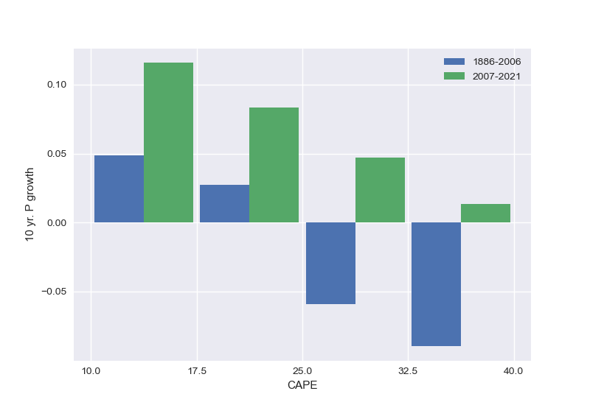

With this in mind, we explore some factors that may have contributed to this distortion in CAPE levels, particularly on S&P 500, and propose appropriate adjustments to restore the CAPE ratio’s long-term returns forecasting power.

**2. Changes in Presumptions and Economic Trends**

**2.1 Interest Rate Regimes and Risk Premiums**

**2.1.1 CAPE and Interest Rate**

Discussion of CAPE thus far has ignored the role of interest rate in valuation. Interest rate is often viewed as something fundamental, such as the price of time itself and yet it is subjected to fluctuations and frequent speculations. Historically, the Fed exerted firm control over short-term rates to achieve inflation targets, controlling long-term rates has been rather difficult. In the aftermath of the Financial Crisis, the Fed introduced measures such as ‘quantitative easing’ in a bid to influence long-term rates, but today they are still determined by the intersection of demand and supply forces.

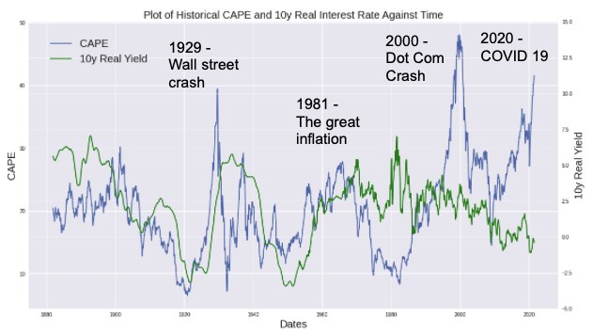

As shown, in the figure above, there is a subtle interplay between the movements of CAPE and 10 year real interest rates. During periods of low interest rates, we find CAPE to be generally higher than the average across sample periods. During periods of high interest rates, we find CAPE to be lower than the average.

**2.1.2 Limitations of CAPE During Changing Interest Rate Regimes**

Discussion of CAPE does not take into account low interest rates. In a low interest regime, bond yields are depressed which makes switching from stock to bonds seem rather unattractive, even if stocks are deemed ‘overvalued’ by CAPE. In addition, interest rates are central to valuation models used by investment analysts. A lower interest rate would decrease the discount rate and therefore justify a higher equity valuation.

As shown in the next section, CAPE fails to justify higher valuations placed on equities, it fails to reflect the relative returns between stocks and bonds and is overall a poorer predictor of expected equity returns during interest rate changes.

**2.1.3 CAPE Based Model**

We start with the regression between real equity return and inverse of log CAPE as Shiller(1996) did[1]:



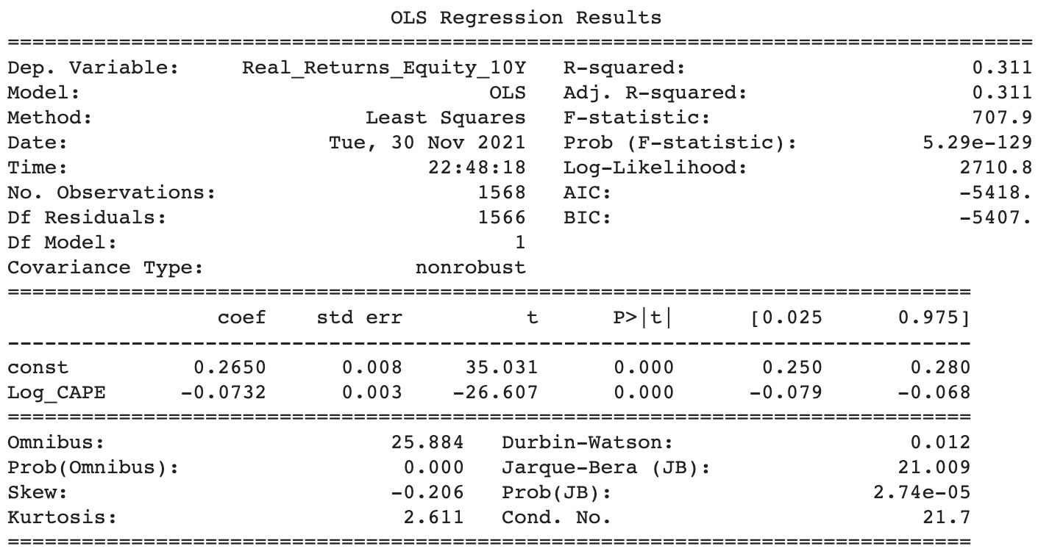

Here the coefficient for log CAPE is -0.073. A high CAPE ratio suggests that equities are overvalued, resulting in low subsequent returns while a low CAPE is suggestive of higher future returns.

One thing worth notice is that in this CAPE based model, the R-squared of this regression is 0.31, which is relatively low and suggests poor predicting power. We hypothesize two reasons for the poor predictive power of CAPE during low interest rate regimes:

1. Bond yields are depressed during low-interest regimes, which prompts investors to allocate more of their portfolio into equity, thus making equity more expensive.
2. Lower interest rates also lowers the discount rate, which increases equity valuation.

It appears that CAPE is not able to capture the relative premium in investing in equity over bonds. And we hypothesis that CAPE fails under changing interest rate regime as:

1. Low interest rates make bonds look extremely unattractive and highly valued, a poor alternative to stocks.
2. Stocks can still generate relatively higher returns even when they are ‘overvalued’ as indicated as CAPE.
3. Falling interest rates decrease the discount rate used in valuation models and the price of equity assets should be priced higher.

**2.1.4 ECY Based Model**

Given the three reasons proposed above, we introduce the new measure proposed by Shiller (2020) adjusting for interest rate regime, which is defined as the inverse current CAPE ratio minus the current 10-year real interest rate, i.e.

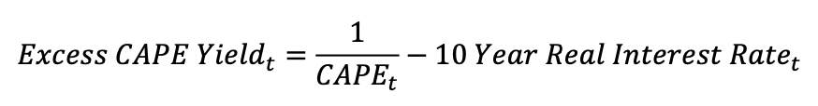

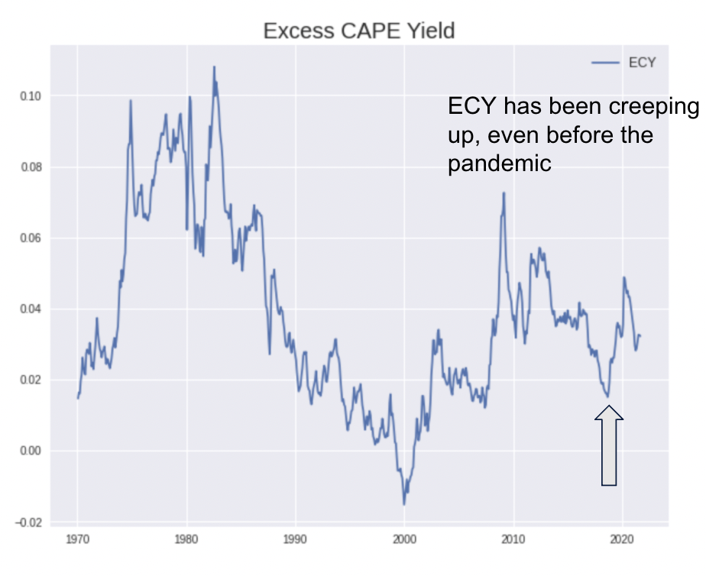

This Excess CAPE Yield (ECY) tells us the premium an investor might expect by investing in equities over bonds. As we can see from the graph, ECY has been high recently, which means stocks are relatively more attractive than bonds. The last time ECY was this high was 1980, where the interest rate was high but so was the inflation. This diminishes the real returns of bonds and makes bonds a riskier investment than equities.

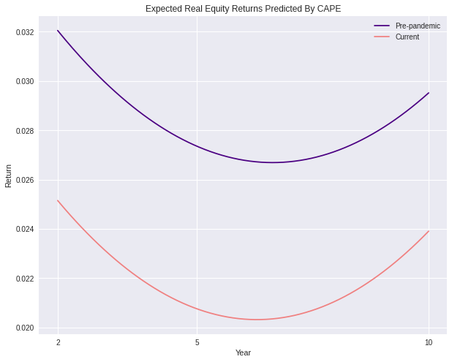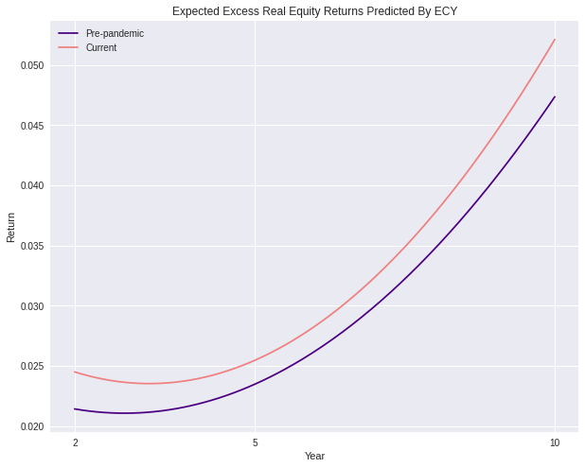

Factoring in 10 years real interest rate, we observe a significant widening between expected excess real returns of equity over bonds since the beginning of the pandemic in the upper plots. And this supports our initial hypothesis that investors have a higher relative expected returns for equities as interest rate declines. Based on this new measure, we rerun the regression to predict the equity real return:



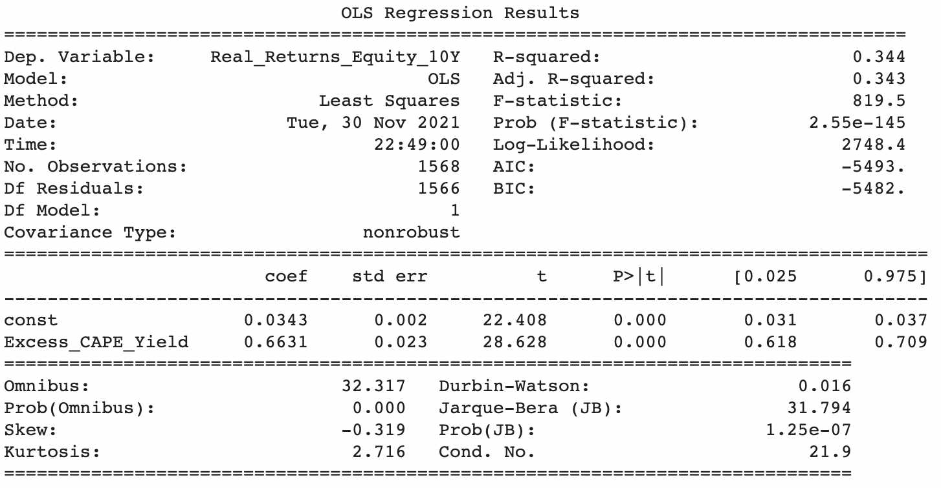

Notice here the R-squared has increased from 0.311 to 0.344, which means combining the long-term bond yield into the model can increase the predicting power.

**2.1.4 CAPE and 10 Year Bond Yield Forecasting Model**

Based on this result, we further include 10 years bond yield as a control variable, and regress the excess equity return on excess CAPE yield and 10 years real interest rate, i.e. running the regression as the adjustment to interest rate regime.



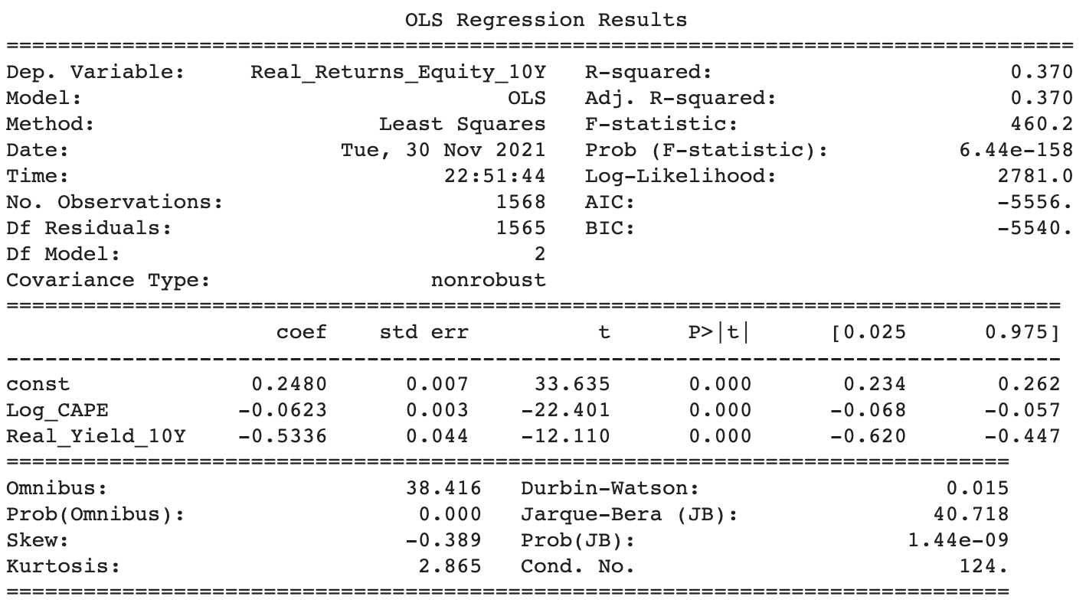

This regression yields the highest R-squared(0.37) so far and all coefficients are statistically significant. The result of the three models we used are as following:

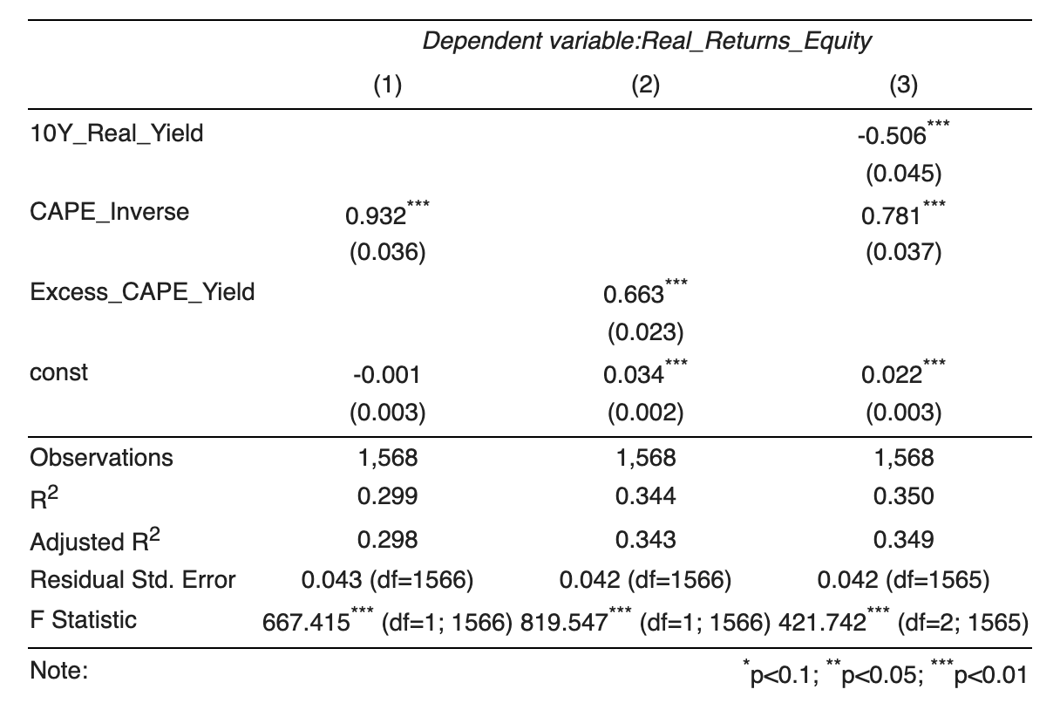

**1881 — 2006 Period Forecast**

To test the predicting power, we use 1881-2006 as our in-sample period to regress the three models. Here is the 10 year in-sample forecast result:

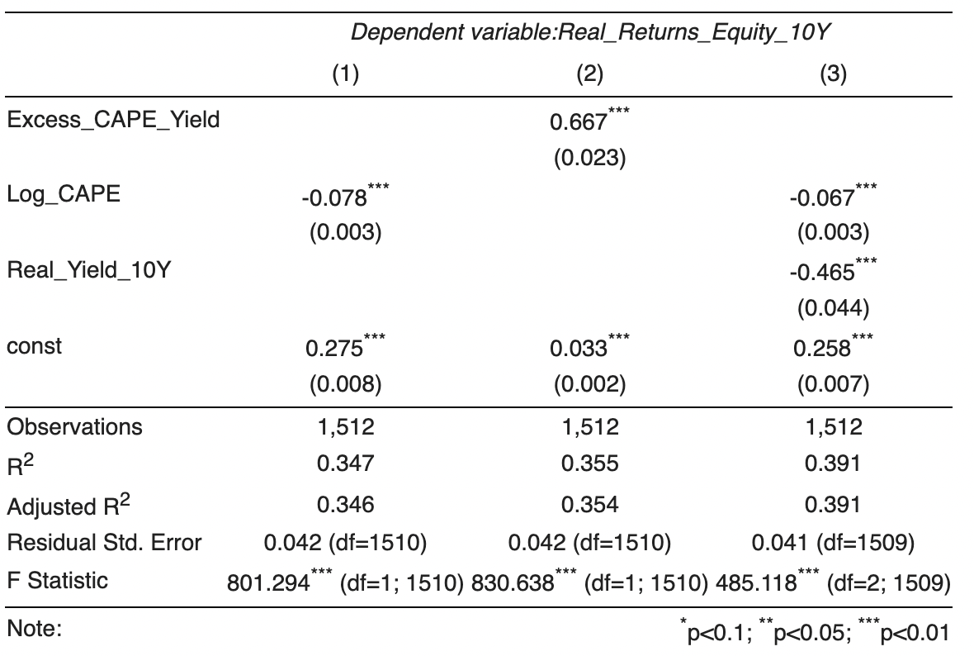

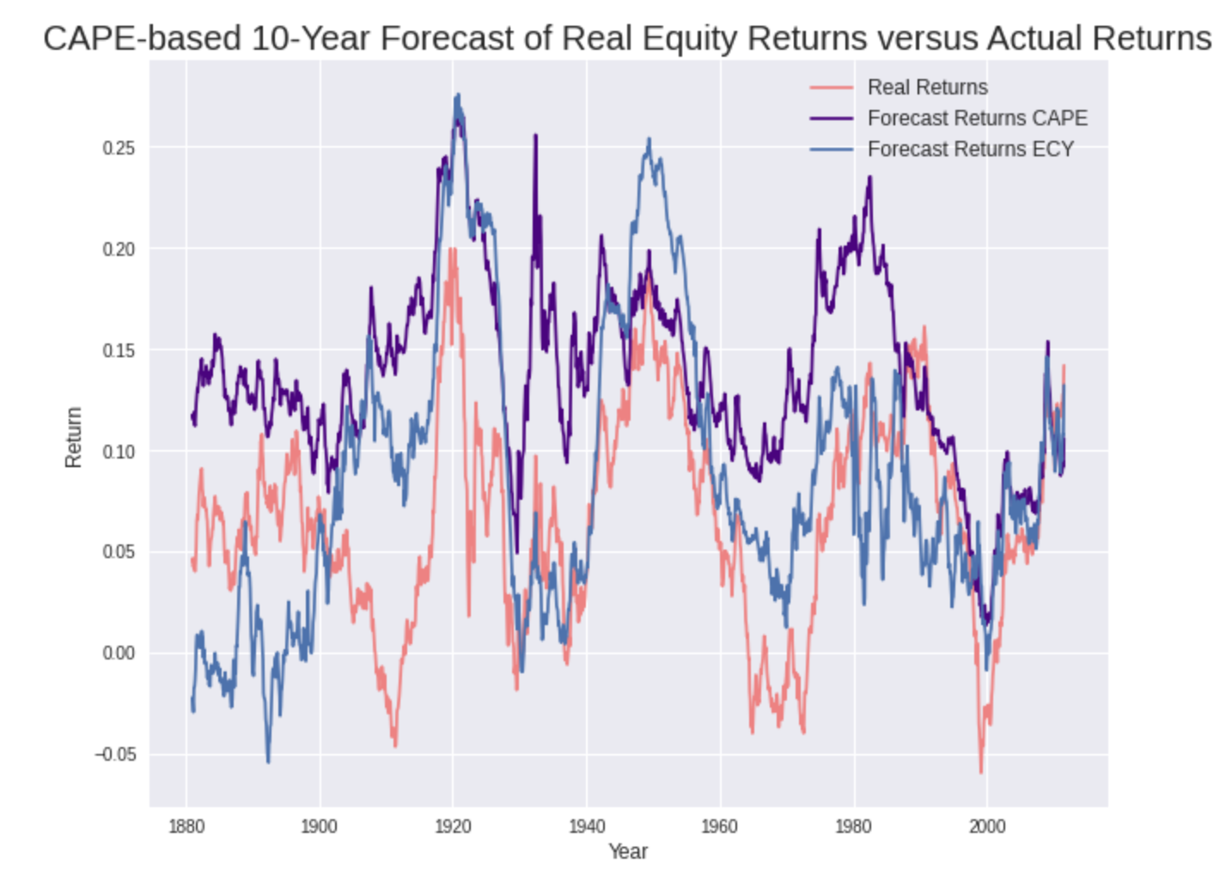

As we can see, the ECY based forecast has the highest R^2 and can capture the movement of equity return better.

**Post-2007 Period Forecast**

Using 2007-2011 as our out-of-sample period, the CAPE based model has a higher R^2 and can better forecast the movement of equity return as well.

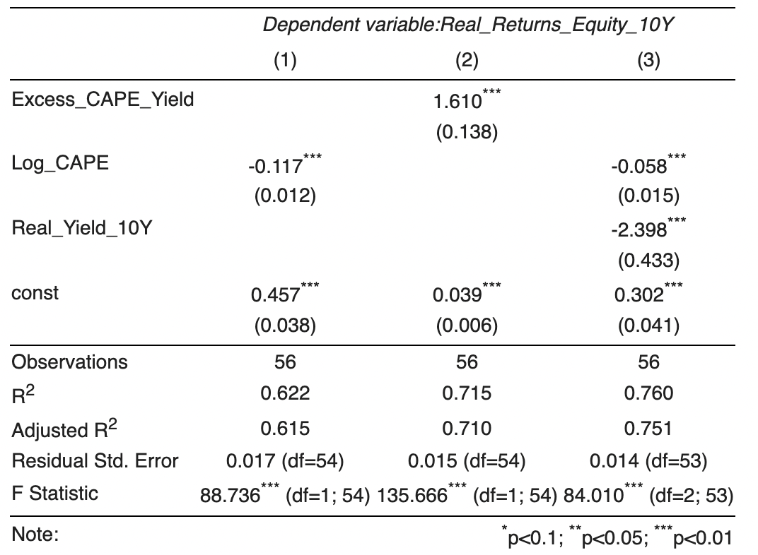

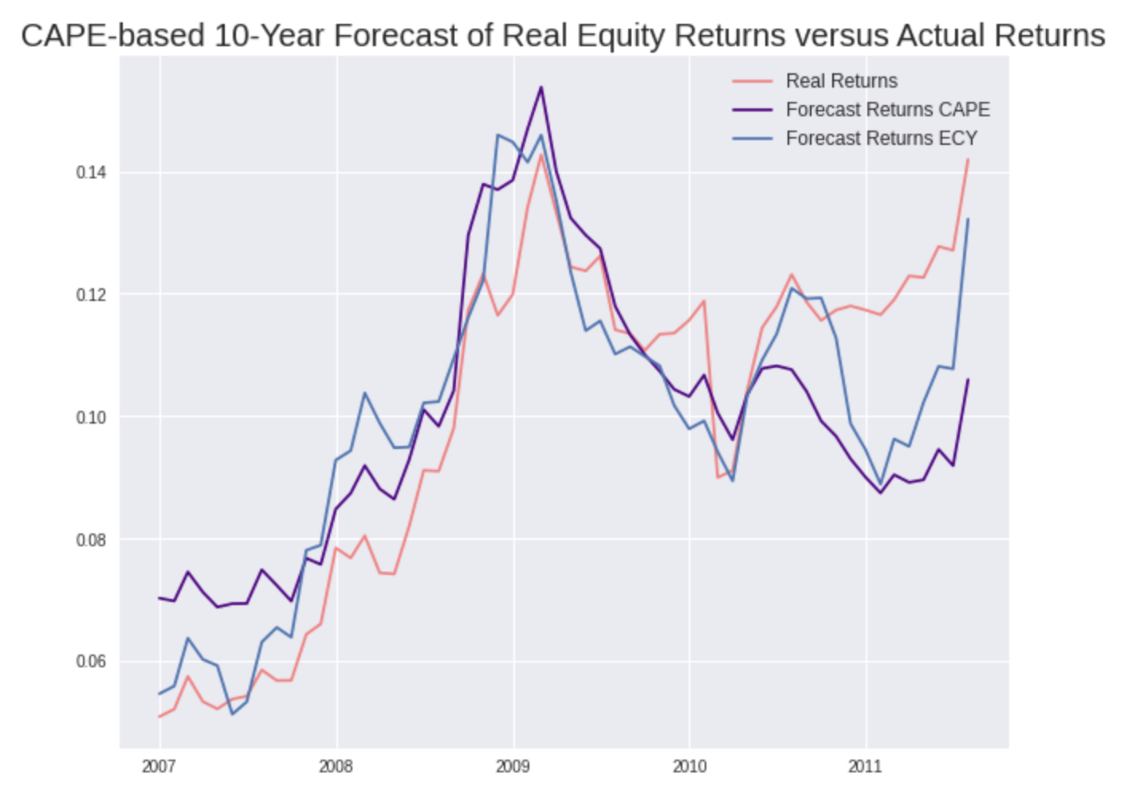

**2.1.4.3 Sub-period Forecast**

The following plot shows the prediction of real equity returns during high real interest rate periods (1930.01 - 1940.01, average 10 years real yield = 4.78%), and we can observe that using ECY as predictor for real equity returns significantly outperformed CAPE during the high real yields period.

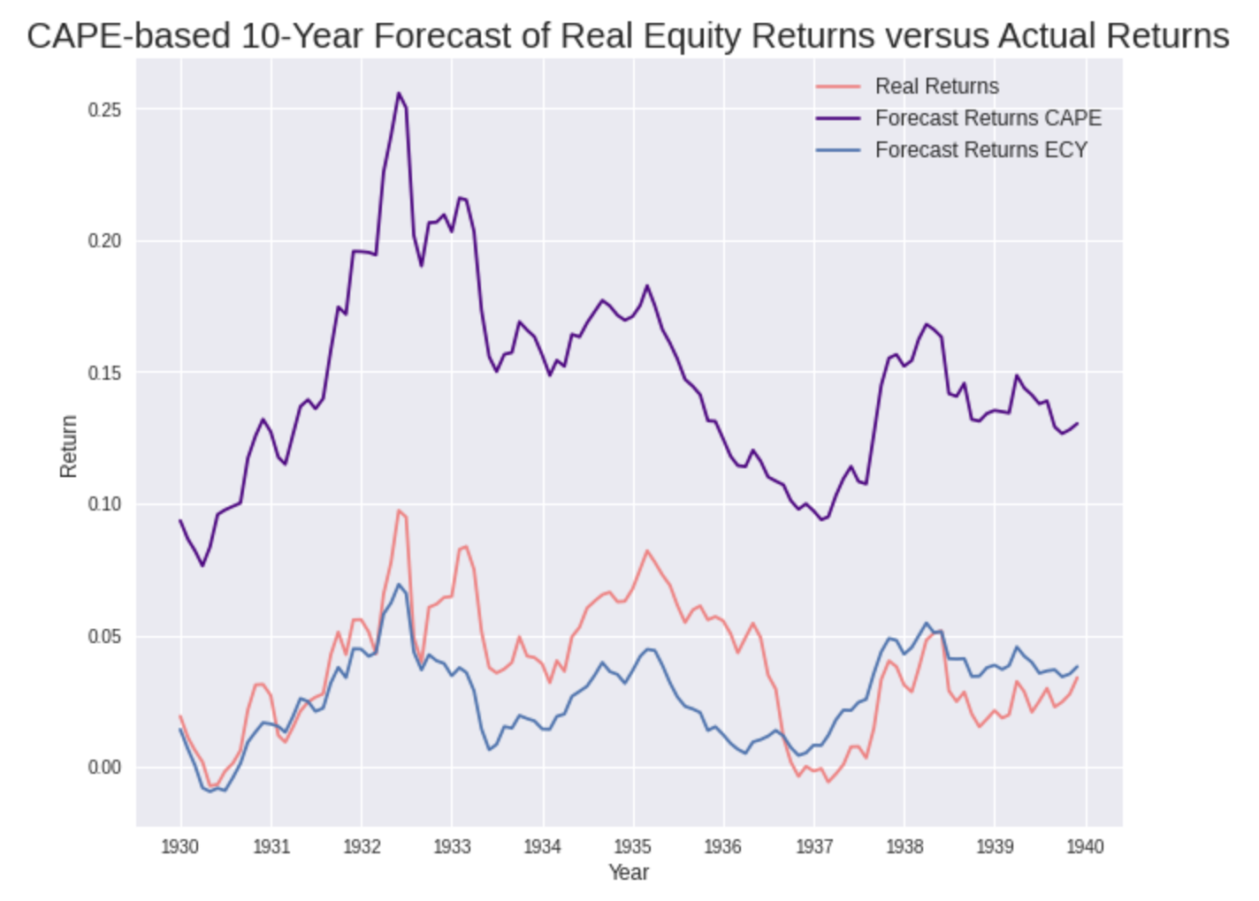

**2.2 Accounting Rules and Standards**

Changes in accounting rules and standards have forced companies to charge large write-offs when assets they hold fall in price, but when assets rise in price they do not boost earnings unless the asset is sold. This change in earnings patterns is evident when comparing the cyclical behaviour of Standard and Poor’s earnings series with the after-tax profit series published in the National Income and Product Accounts (NIPA). For the 2001-02 and 2007-09 recessions, S&P reported earnings dropped precipitously due to a few companies with huge write-offs. Yet before 2000, the cyclical behaviour of the two series was similar. Downward biased S&P earnings send average 10-year earnings down and bias the Cape ratio upward.

**2.2.1 Overview of Accounting Rules Change and Impact on CAPE**

The calculation of CAPE uses data from S&P “reported” earnings, which are formulated in accordance with Generally Accepted Accounting Principles (GAAP). Pre 2001, GAAP required goodwill amounts to be amortized. In 2001, the standard changed and FAS 142 was introduced which requires companies to annually test goodwill for impairment. Thus, GAAP is an inconsistent measure for comparison between the two periods. This issue about the earnings inconsistency is not new - Jeremy Siegel, professor at the Wharton School of Business, has been raising this issue since at least 2008 [3]. In the fourth quarter of 2008 alone, write-downs were large enough to wipe out almost all of the earnings in the index. If the same standards had been applied during the painful recessions of the mid 1970s and early 1980s, or the M&A binge that followed, reported earnings would have been significantly lower.

**2.2.2 Proposed Modification and Data Collected**

Since the earnings provided by the GAAP are inconsistent between the two periods, we propose to use a more consistent measure. One such measure is the time series of trailing twelve-month earnings provided by Bloomberg (T12_EPS_AGGTE). The following plot shows a comparison of the GAAP earnings used in the original CAPE formulation and the Pro-Forma Earnings time-series collected from Bloomberg.

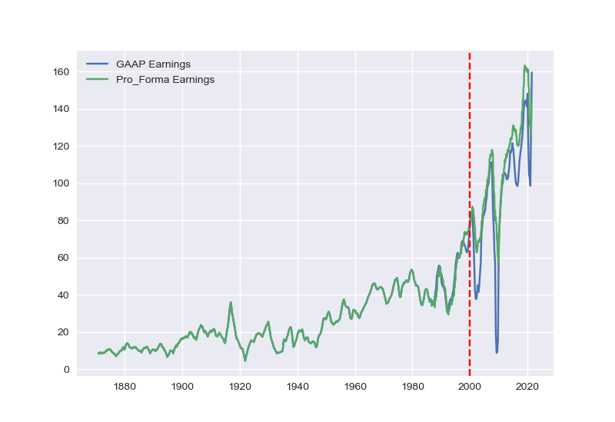

For most of history, the two series closely tracked each other. But since the beginning of the last couple of decades, they’ve significantly deviated, especially in periods around recessions. The biggest reason for the deviation is the introduction of FAS 142, first implemented in 2001, near the break in the chart, which is identified by the dashed red line. With this prelude, we can fix the accounting inconsistency in Shiller’s original CAPE by using pro-forma earnings instead of the GAP earnings. This suggests that we modify the CAPE as follows:

$Modified CAPE =\frac{Price}{Pro-Forma Earnings}$

Here, we use a ten-year average of the pro-forma earnings instead of the GAAP earnings in the denominator. This abstracts away from business cycles but detects gradual changes. A comparison of this modified version of the CAPE with Shiller’s original CAPE is shown below. Incorporating Pro-Forma Earnings shifts the CAPE downwards in the post-2001 periods.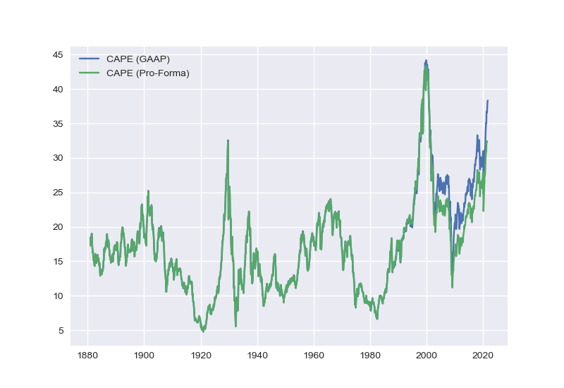

**2.3.2 Results of Accounting Modified CAPE**

Taking the modified CAPE that accounts for a more consistent measure of corporate earnings, we performed regression on 10-year annualized stock returns vs. our adjusted CAPE using trailing twelve-month earnings. We performed regression for the original period (1881-2006) as well as on the new period (2007-2011) to evaluate the performances of the new metric. We also analyzed the entire time period in the data to measure the metric overall performance and how it compares with the original metric. The goal is to adjust CAPE so that it can outperform the original metric in the new time period, and perform just as well in the older time period.

Below, we have results for the regression output for the three periods 1881-2006, 2007-2011 and 1881-2011. As can be seen from the R2 value, the adjusted CAPE performs on par at predicting the 10-year annualized stock returns for the original period (1881-2006) and outperforms the original measure on the new period (2007-2011).

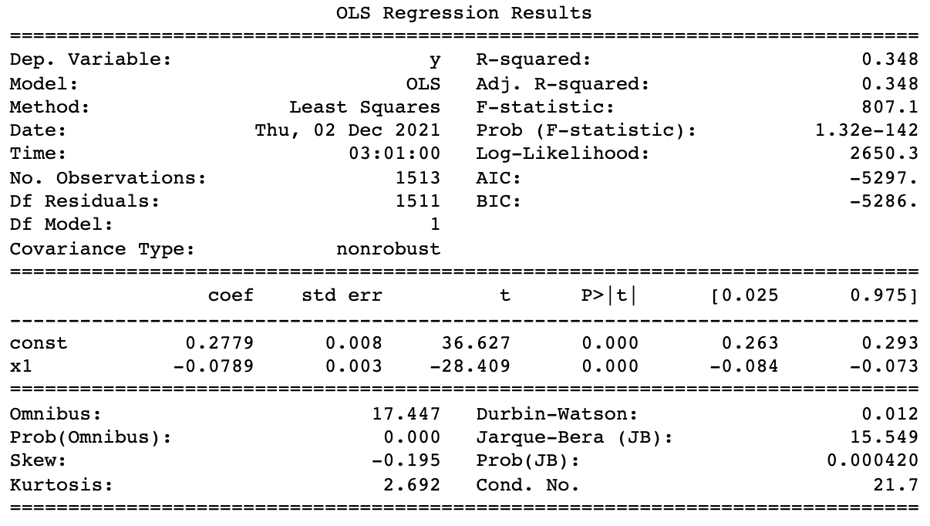

*1881-2006 Modified CAPE ratio*

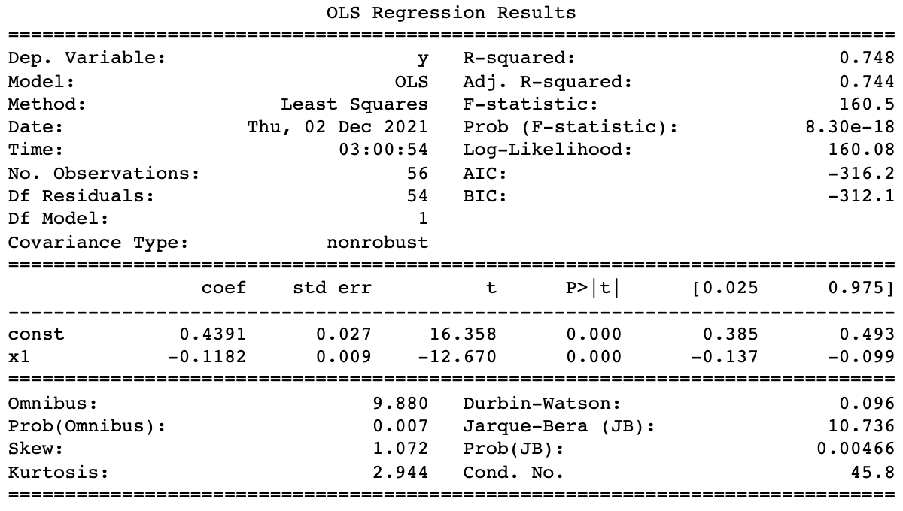

*2007-2011 Modified CAPE ratio*

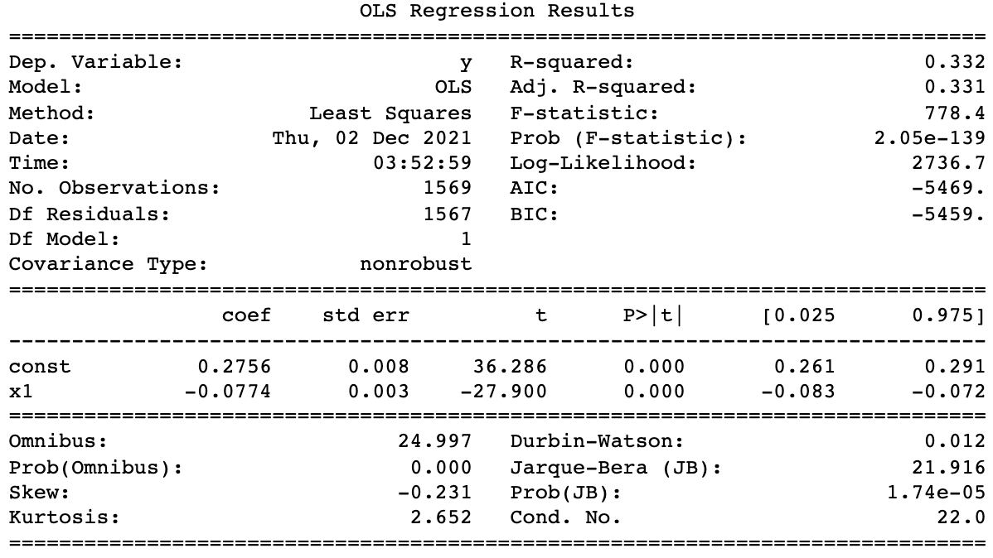

*1881-2011 Modified CAPE ratio*

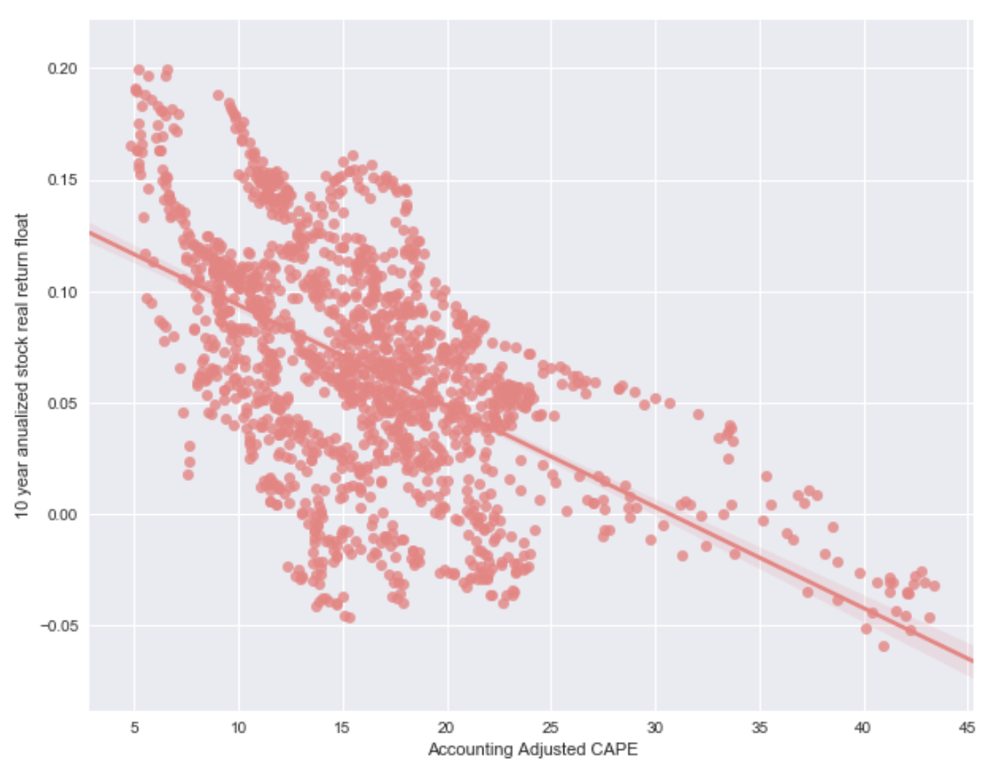

**2.3 Tax Regulations and Tax Rates**

Changing tax regulations and tax rates are problems for the original CAPE ratio. New presidential administrations approve many tax policy changes that affect annual corporate earnings, which is an essential component of the CAPE ratio. Since the original publishing of Shiller’s paper on the CAPE ratio, new presidential administrations have implemented various tax reforms to promote social welfare or to boost the economy. As tax policies change dynamically from year-to-year, an adjustment to the original CAPE ratio is necessary to account for these changes to provide a more accurate perspective of the present-day market value.

**2.3.1 Overview of Tax Code Change and Impact on CAPE**

Tax rates constantly change, from one presidential administration to the next, and onwards. For instance, in December 2017, Congress passed the Tax Cuts and Jobs Act (TCJA) into law, representing the largest tax reform in three decades. Specifically, the corporate tax rate was changed from a tiered tax rate ranging from 15% to as high as 39% depending on taxable income to a flat 21%. The top federal corporate income tax rate was lowered from 35% to 21% beginning in 2018. The change in tax rate makes the original Shiller P/E unreliable due to its mean-reversion assumption.

Regarding the Shiller P/E, the main idea is to estimate a long-term mean-reverting fundamental value without being distorted by short-term issues. As it takes a ten-year average of earnings, the Shiller P/E implicitly assumes that the tax rate will mean-revert to previous levels4. Effectively, the Shiller P/E computes an expected value of the corporate tax rate across the past 10 years and uses it as the tax rate to value a company’s fundamental earnings. The 10-year tax rate that the original Shiller P/E used is:

35% x 0.6 + 21% x 0.4 = 29.4%

However, the present-day tax rate is 21%, so investors should be expecting a 21% tax rate instead of 29.4% going forward. The higher tax rate used in the Shiller P/E has contributed to a higher ratio indicating that the market is overvalued. Nevertheless, the S&P 500 continues rising. To align with the market’s future expectations, we propose to adjust the earnings by taking an average of the last ten years of pretax income and applying the current tax rate.

**2.3.2 Proposed Modification and Data Collected**

To account for dynamic tax rates, we use the present-day corporate tax rate on the 10-year average pretax earnings, instead of using an average tax rate across 10 years. We use this approach to obtain the modified earnings-per-share (EPS) using the present-day number of shares. In detail, we need to obtain the pretax earnings and adjusted number of shares after a share buyback. Buyback is share repurchase when a firm buys its outstanding shares to reduce the number of shares available in the market. Buybacks create earnings per share growth by decreasing the number of shares. In the original paper, Shiller approaches this issue by reinvesting dividends, which makes S&P look more expensive. However, intuitively this should make the S&P cheaper given that there are fewer shares available which result in a higher EPS, and thus lower P/E.

Below are the overall adjustments we have done:

1. Adjust earnings to real number based on index CPI and interest rate
2. Obtain the pretax earnings per share by dividing (1- current tax) at each period
3. Obtain the number of shares outstanding in each period after buyback. Buyback data was extracted based on S&P Global research on Buybacks
4. Calculate the adjusted EPS based on current tax rate and share counts by applying the Equation



(Adjustment to 10-Year Average EPS Calculation for CAPE)

1. Derive the modified CAPE based on the adjusted EPS
2. Perform regression on S&P return vs. modified CAPE

**2.3.2 Results of Tax Modified CAPE**

Taking the modifications we made to the original CAPE to account for changing corporate tax rates, we performed regression on 10-year annualized stock returns vs. our adjusted CAPE. As corporate tax rates have fluctuated significantly in the more-recent time period after 2006, we performed regression for the original period (1881-2006) as well as on the new period (2007-2011) to evaluate and compare the performances of both metrics. Finally, we analyzed the entire time period in the data to measure overall performance. The goal is to adjust CAPE so that it can outperform the original in the new time period, and perform just as well in the older time period.

Below, we have results for the regression from 1881-2006. As can be seen from the R2 value, it does a fairly

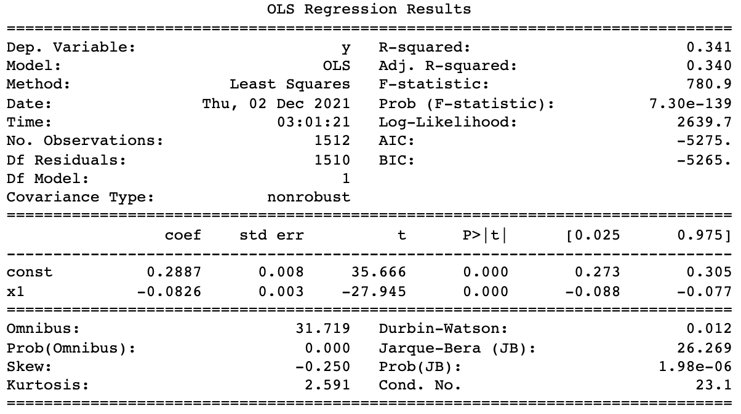

*Regression analysis: 1881-2006 Modified CAPE ratio*

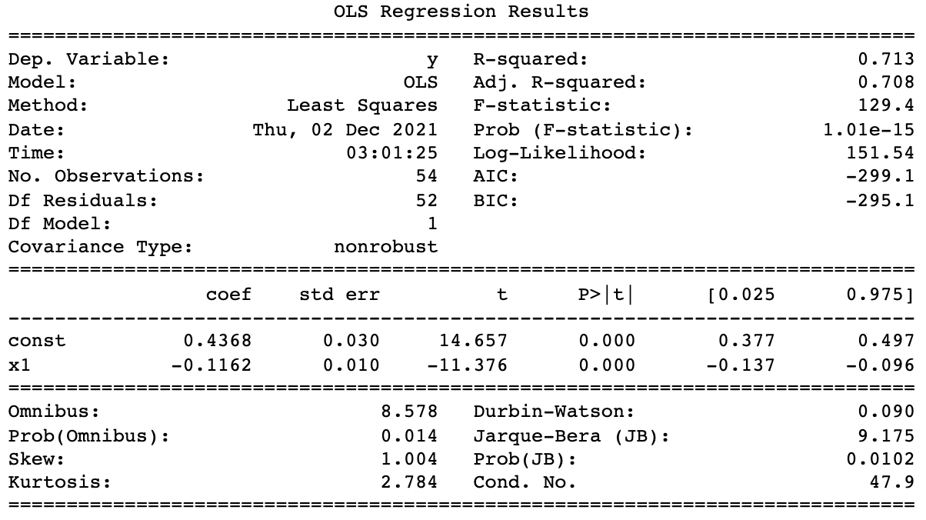

*Regression analysis:2007-2011 Modified CAPE ratio*

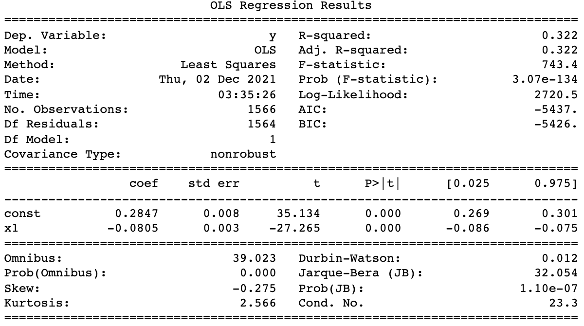

*Regression analysis: 1881-2011 Modified CAPE ratio*

From the result, the R2 remains roughly unchanged which indicates the tax rate did not differentiate much before Shiller published the paper. However, we can see there is an obvious increase in R2 for 2007-2011 regression analysis (from 0.662 to 0.713). This implies our adjusted CAPE has a tighter fit with the 10-year forward return after 2007 and it complies with our knowledge that the tax rates were much more dynamic and volatile in that period, which further vindicates that our adjustment does contribute to a better prediction of the long term return. In contrast, period 1 had a more stable tax rate, thus our adjustment should not make much difference in theory. R2 also has a slight increase from the entire period 1881-2011, which also shows an overall improvement in performance with tax-adjusted CAPE.

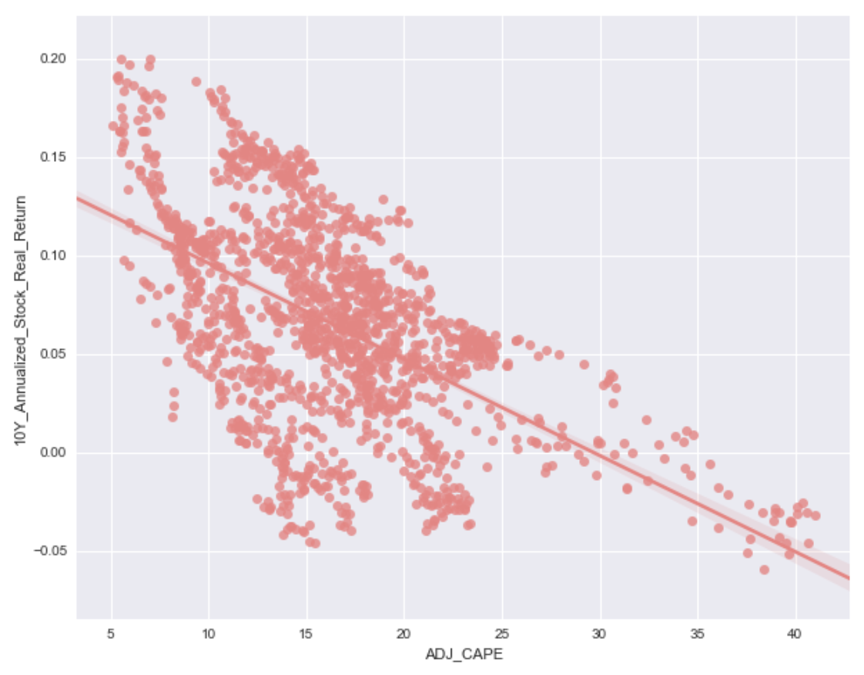

*Plot - 10 year annualised return against adjusted CAPE*

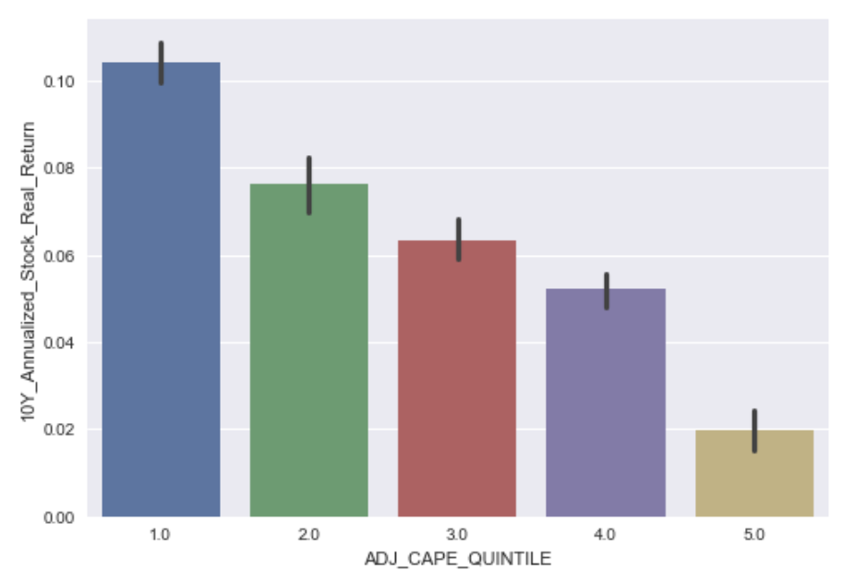

*Average 10-Year Stock Return for Quintiles of Adjusted CAPE*

Splitting our adjusted CAPE values into quintile bins, we can see that the average 10-year stock return for each of the bins follows our expectation. Lower values of the adjusted CAPE indicate that the market is undervalued and correspond to greater average returns, while higher values of the adjusted CAPE indicate that the market is overvalued and correspond to lower average returns.

**2.4 Composition of Market Index**

**2.4.1 Overview of Change in Market Index Composition and Impact on CAPE**

With the grand expansion of technologies and other emerging industries, the current U.S. equity market has experienced big changes in its composition mixes. S&P 500 has long been treated as a proxy standard for the U.S. equity market. In Shiller’s calculation, the S&P 500 P/E ratio is directly obtained without considering potential index composition changes. In his practice, at a given time t, Shiller computed CAPE ratio by taking the SPX price Pt, then dividing the rolling 10-year EPS of SPX. However, companies joining or dropping out of S&P 500 during the past ten years will not be accounted for, causing a mismatch of stock constituents between the numerator and the denominator of the CAPE ratio. Thus, we should adjust CAPE ratio calculations to account for such index composition changes.

**2.4.2 Proposed Modification and Data Collected**

To adjust index composition shift, we propose two distinct solutions:

**Solution I:** Assign different weights when computing 10 year rolling P/E ratio:

The intuition is that we hope to assign a higher weight to more recent years as they would resemble the actual S&P 500 constituents at time t to a greater extent. As a result, we assign higher weights to more recent EPS whereas lower weights to less recent ones when calculating the rolling 10-year EPS (denominator of CAPE ratio).

The way we currently do this is assigning weight to year, assuming it is the current period, and normalizing the time series so that their weights sum up to 1. Thus, we propose a version of modified CAPE with an equation of:

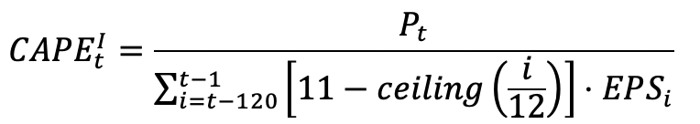

The EPSi in the equation means monthly EPS in Shiller’s data (after linear interpolation and CPI adjustment).

**Solution II:** Use exact index constituents to compute CAPE ratio

In order to exactly match the stock composition mix between numerator and denominator of CAPE ratio, at each time t, we propose to calculate the rolling EPS using the historical EPS of each constituent of SPX at time, rather than using historical SPX’s EPS (which may include stocks that have been removed or may not include stocks that have been newly added). Incorporating such idea, we propose another version of modified CAPE ratio as:

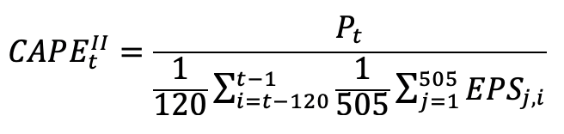

To examine and test this proposal, we collected S&P 500 index constituent companies on a quarterly basis from 1990 to 2011. Though the actual shift in the index happened arbitrarily with time, we believe our data with quarterly frequency can capture the majority of shifts in the index as we are looking at a horizon of 10 years P/E ratio. In terms of timing, we decided the year range from 1990 to 2011. Looking at Shiller’s original CAPE ratio, it had a high predicting power of future stock market returns prior to 2000, but lost its predictability after that. Thus, we hope to test our modified CAPE in the period where Shiller’s model doesn’t perform well enough. Since we are investigating the years 2000-2021, we need 1990-2011 P/E data as we’re computing trailing 10 years P/E ratios.

**2.4.3 Results of Modified CAPE based on market index composition**

**Modification I:**

After adjusting weight when computing rolling 10 years P/E, we compare our new modified CAPE with the original Shiller’s version. From 1881-2006, we achieved a similar R^2 value (0.338 in new CAPE vs. 0.347 in Shiller’s CAPE). From 2007-2011, our modified CAPE ratio underperformed in terms of the R^2 value (0.527 vs. 0.622). To graphically show the adjusted CAPE ratio vs. original CAPE ratio, the curve in general matches with the original one, with corrections at the extreme values.

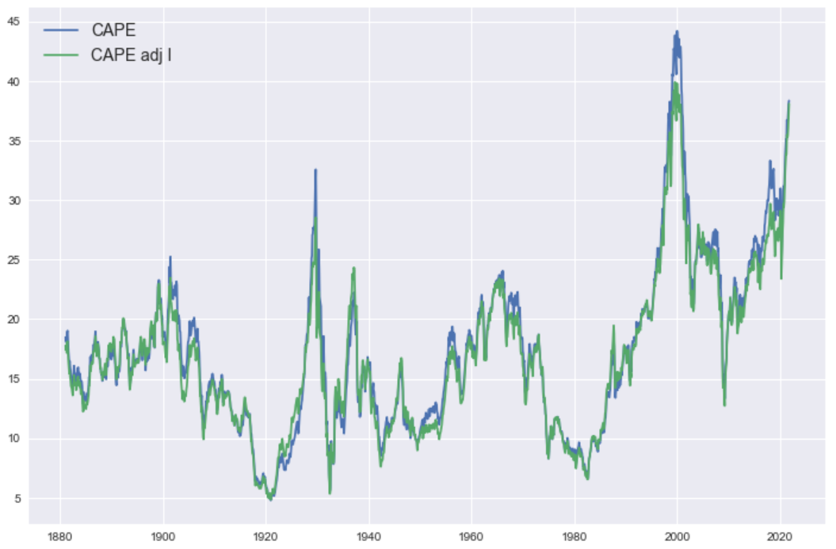

**Modification II:**

Looking at our second modification for matching stock constituents, we achieved lower R^2 compared to the original CAPE (0.413 vs. 0.878) during the period 1990-2011. In the graph shown below, we plot both the original CAPE and our modified CAPE curve. The y-axis to the left is CAPE ratio numbers and right y-axis is future 10 year stock market returns. We can see the new CAPE ratio mimics the movement of Shiller’s CAPE, but with larger volatilities in its movements. This makes sense intuitively as we tract market index changes in a more timely way.

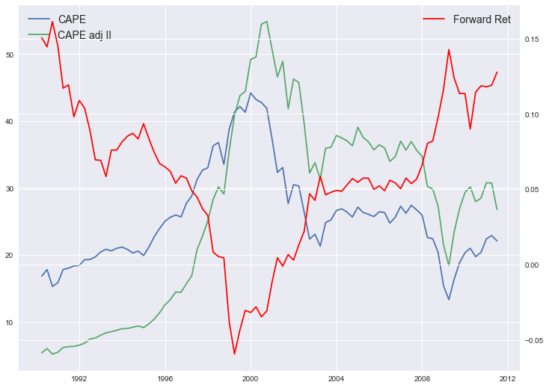

**3. Results and Discussion**

**3.1 Regression Analysis of CAPE vs. Modified CAPE**

Taking all the modifications we made to the original CAPE for each economic trend that we analyzed, displayed below are the overall results of the CAPE ratios’ explanatory power on 10-Year annualized stock returns on regressions. The R2 value can be compared for the original time period that Shiller tested, the modern time period, and the entire duration of the data.

| **CAPE Ratio** | **R2 (1881-2006)**  **Period 1** | **R2 (2007-2011)**  **Period 2** | **R2 (1881-2011)**  **Full Period** |
| --- | --- | --- | --- |
| Original CAPE | 0.347 | 0.662 | 0.314 |
| Adjustment for Accounting | 0.348 | 0.748 | 0.332 |
| Adjustment for Interest Rate Regimes | 0.391 | 0.760 | 0.370 |
| Adjustment for Market Index Composition | 0.338 | 0.527 | 0.304 |
| Adjustment for Tax Rates | 0.341 | 0.713 | 0.322 |

From the R2 values for each adjustment we made in each time period, it can be seen that the Adjusted CAPE values perform just as well as the original CAPE in the original (1881-2006) period, with a range of 0.341 - 0.391, compared to the original CAPE’s R2, 0.347. Furthermore, we can see that the Adjusted CAPEs perform significantly better in predicting 10-year market returns for the modern day period (2007-2011) than the original CAPE. Three of the adjustments have above a 0.71 R2, compared to the original which has a 0.662 R2. This shows that the original CAPE can be modified to account for changes in recent economic trends and presumptions, while not affecting its overall predictive power to value the market. To confirm this observation, we also display the R2 values of each CAPE across the entire time period, and we can see that most of these adjustments provide greater explanatory power than the original CAPE for the overall time frame. This indicates that our adjustments to the original CAPE have improved its predictive power by accounting for key economic changes, while maintaining the power of its original intended use: to value companies based on long-term performance, instead of just present-day performance which can skew the performance in the short-term.

**4. Summary and Conclusion**

From our regression results, it can be seen that the modifications we proposed to the original CAPE ratio added more explanation power to the S&P returns R2 values and were improved for the newer period where many presumptions and economic trends have changed. The purpose was to find adjustments that can be made to improve CAPE’s predictive power on market returns for the recent period (2007-present), while maintaining its high performance on the original period (1881-2006). Our regression results show that we were able to make modifications to the original CAPE with additional data that preserved its past performance and improved modern performance with changing economic trends. Furthermore, the Adjusted CAPEs we made solved one major issue of the original CAPE: the ratio was always too high and indicated that the market was always overvalued.

For next steps, taking the modifications we made to the original CAPE, we can implement it into a trading strategy to try to time the market and buy when the Adjusted CAPE indicates that the market is undervalued and sell when it indicates that the market is overvalued. We can build a dynamic trading strategy based on changing economic trends with the additional data that we collected for each modification we made. It is also possible to apply the Adjusted CAPE ratio to predict market corrections and market crashes in the near future. For example, Adjusted CAPE can be used as an indicator of an imminent 20% decline in the market.

Overall, the CAPE ratio is still a useful measure for assessing market value and returns, and predicting long-term growth without being heavily impacted by cyclical adjustments that affect corporate financials. Despite the limitations that the original ratio had, additional data and information can be collected to make small adjustments to the formula to account for changing economic trends and presumptions. This can greatly improve its predictive power in more recent years of modern finance and give value investors a better sense of the present market state relative to the past.

**References**

[1] Campbell, J. Y., & Shiller, R. J. (1998). Valuation Ratios and the Long-Run Stock Market Outlook. *The Journal of Portfolio Management*, *24*(2), 11–26. <https://doi.org/10.3905/jpm.24.2.11>.

[2] Shiller, R. J., Black, L., & Jivraj, F. (2020). CAPE and the COVID-19 Pandemic Effect. Available at SSRN 3714737. <https://dx.doi.org/10.2139/ssrn.3714737>.

[3] Siegel, J. (2013) Don’t put faith in Cape Crusaders, The Financial Times. Available at <https://www.ft.com/content/496a3844-0013-11e3-9c40-00144feab7de>.

[4] ​​Klassen, Damien. “Trump Broke the Shiller P/E. Here Is a Simple Fix.” *Nucleus Wealth*, 1 Sept. 2021, <https://nucleuswealth.com/articles/trump-broke-the-shiller-pe-here-is-a-simple-fix/>.

1. We are using the logarithm of CAPE instead of the inverse of CAPE in the regression.